SENET Company

Request for Proposal

December 2020

- Executive Summary of the proposed architecture
Additionally, Fiducia life Assurance Company of America looking for a partner and asked of us to help them to improve and upgrade their Internet facilities equipment and this partnership can benefit both companies. With the new branding, joint venture will contribute to selling more products, expand the customer base and the promote market of products from both companies. Fiducia life Assurance Company of America recently obtained an update of the leading database management software in the market – Oracle Database. Fiducia life Assurance Company of America is confident that the database, along with Oracle Developer Tools, will become the foundation of a core system that will address the company’s critical needs and give the organization an enormous competitive edge over its rival in the insurance industry.
In order to proposed this project to Fiducia life Assurance Company of America, the proposed objectives following;
- Improving their hub connecter and router
- 50 Computers into a new fast computer
- Buying a new Dell Power edge NX3240 latest generation PowerEdge rack mount server technology and;
- Provide a technical support team to help manage and maintain their computer hardware and software systems. Their skills are an asset to the company, as they assist in resolving technical issues concerning customer's accounts or company software infrastructure.
- Upgrade their iPad Pro, or Similar high-end Android tablet
- Provide a training services on the use and maintenance of the Facilities/ Infrastructure vendor products
Senet Company will act as broker and liaison between our chosen real-life technology partner, Acer incorpation, Samsung incorpation, Amazon, Lazada, eBay, Forever 21. needs which have the budget of P6, 000,000.00 and needs to negotiate to reduce the amount of purchase. So the in the partnership between Acer incorpation, Samsung incorpation, Amazon, Lazada, eBay, Forever 21 the Company that that to provide a Facilities that we needed for material network facilities including (router, computer, hub connector, server, Ipad Pro
- Functional Requirements

- FUNCTIONAL REQUIREMENTS CHECKLIST
Server Requirements |  | Proposed Server Functionalities
Database Management System | Conform to newest Oracle Database release | Supports Oracle DB and can run latest release of the Oracle  Database
Operating System | Unix, Unix-like  OR  Microsoft Windows Server | Microsoft Windows Server 2016

Client Requirements |  | Proposed Client Specifications
Operating System (OS) | Microsoft Windows, or  Unix/Unix-like or  MacOS | Windows 10 Pro
Front-end tools | Can run latest release of Oracle Developer | Client specifications passed system requirements of Oracle Developer
Multimedia | Supports playback of at least 1080p Video (4K preferred) | Monitor has Display Optimum Resolution: 1920x1080

Network Requirements |  | Proposed Client Specifications
TCP/IP | Supports TCP/IP Network Protocol | Network support is Support by the default
IPX/SPX | Supports SPX/IPX Network Protocol | Network does support the routing

- TECHNICAL REQUIREMENTS - PowerVault NX3240
Server Requirements |  | Proposed Server Specifications
Bit Computing | 64 – Bit Computing | Support by the default
Number of Cores | Minimum of 6 Cores | Intel® Xeon® Bronze 3204, Silver 4208 or Silver 4214 processors-
Clock Speed | Minimum of 3.6GHz | Intel® Xeon® Bronze 3204, Silver 4208 or Silver 4214 processors
RAM | Minimum of 32GB RAM | Up to 64GB memory
Disk Storage | Minimum of 8 TB Disk storage. | Up to 64GB memory
Tape Drives | Supports DAT Tape Drive | Up to 192TB* raw capacity
SVGA Monitor | Monitor | -

Client Requirements |  | Proposed Client Specifications
Bit Computing | Minimum of 2 Cores | Enabled by default
Number of Cores | Minimum of 2 Cores | 6 CPU Cores
Clock Speed | Minimum of 3.0 GHz | 3.6GHz base frequency  4.2GHz max boost frequency.
RAM | Minimum of 8GB RAM | 8GB (1x8GB) Speed
Disk Storage | Minimum of 2 TB Disk storage. | Capacity: 2TB
Monitor | 22” Monitor or better | 1920 x 1080 Full HD Resolution and 75Hz Refresh Rate

Mobile Requirements |  | Proposed Mobile Specifications
Replace 2nd Generation iPads | high-end Android Tablet | Samsung Tab 2 Generation Ipads

- Company Profile
Senet Inc. is an American Low Power Wide Area Network (LPWAN) provider for IoT/M2M applications. The Senet Network is described as "the first and only public provider of LPWA networks with class leading LoRa® modulation for IoT/M2M applications in North America”. Its platform is positioned to meet the needs of the growing “Internet of Things” (IoT) ecosystem.[1]

The Senet Network adheres to the open global networking standards as proposed by the LoRa® Alliance, and enables low power, machine to machine (M2M) connectivity across wide geographic areas. It is designed to remove the barriers traditionally associated with managing remote devices such as reliability, range, battery life, bidirectional capability, mobility, and cost.

The Senet Network
The Senet Network is differentiated from other LPWANs by being an open standards network that is known for deploying and running the largest revenue-generating application.[12]

The Senet Network’s fully enabled two-way architecture provides data communication from sensors over long distances at a lower cost, longer range, and longer battery life than cellular networks.[13] Battery life is determined by how often the devices are set to transmit data and how much data is being transmitted. Transceiver batteries can last as long as 10 years.[14]

Senet partnered with the LoRa® Alliance and Semtech to incorporate LoRaWAN technology into the Senet Network.[15] With the deployment of LoRaWAN technology, the Senet Network provides unique benefits that are not found in other LPWAN technologies.[16] These benefits include bidirectional communication, mobile device support, adaptive data rate support, and strong built-in security features using AES-128.

- Company Profile of our partnership
*Acer Incorporated, *Samsung Incorporated, *Amazon, *Lazada, *eBay, *Forever 21 and shopee

Acer Incorporated is Taiwan's leading exporter and the world's fifth largest computer manufacturer. Taiwan's high-tech industry pioneer Stan Shih cofounded Acer. Over the years Shih guided his company through several corporate restructuring processes as well as financial ups and downs of the 1980s and 90s.

Samsung Incorporated It comprises numerous affiliated businesses, most of them united under the Samsung brand, and is the largest South Korean chaebol (business conglomerate). Samsung was founded by Lee Byung-chul in 1938 as a trading company. Its affiliate companies produce around a fifth of South Korea's total exports.

Amazon Incorporated is an American multinational technology company based in Seattle, Washington, which focuses on e-commerce, cloud computing, digital streaming, and artificial intelligence. It is considered one of the Big Five companies in the U.S. information technology industry, along with Google, Apple, Microsoft, and Facebook The company has been referred to as "one of the most influential economic and cultural forces in the world", as well as the world's most valuable brand.

Amazon was founded by Jeff Bezos in Bellevue, Washington, on July 5, 1994. The company started as an online marketplace for books but expanded to sell electronics, software, video games, apparel, furniture, food, toys, and jewelry. In 2015, Amazon surpassed Walmart as the most valuable retailer in the United States by market capitalization. In 2017, Amazon acquired Whole Foods Market for US$13.4 billion, which substantially increased its footprint as a physical retailer. In 2018, Bezos announced that its two-day delivery service, Amazon Prime, had surpassed 100 million subscribers worldwide.

eBay Incorporated. operates as a commerce company, which engages in the provision of investments and acquisitions to help enable commerce on platforms for buyers and sellers online or on mobile devices. It operates throught the following platforms: Marketplace, Classifieds and StubHub. The Marketplace platform include online marketplace located at www.ebay.com, its localized counterparts and the eBay mobile apps. The Classified platform focuses in collection of brands such as mobile.de, Kijiji, Gumtree, Marktplaats, eBay Kleinanzeigen and others. The StubHub platform gives online ticket platform located at www.stubhub.com, its localized counterparts and the StubHub mobile apps. The company was founded by Pierre M. Omidyar in September 1995 and is headquartered in San Jose, CA

Forever 21 incorporated, stylized as FOREVER 21, is an American fast fashion retailer headquartered in Los Angeles, California. Forever 21 began as the store called Fashion 21 with 900 square feet (84 m2) in Highland Park, Los Angeles, in 1984, and has grown into the clothing lines Forever 21, XXI Forever, Love 21 and Heritage with over 700 stores in the Americas, Asia, the Middle East and the UK.

Forever 21 is known for its fashionable and trendy offerings with very low pricing, while it is an epitome of the rapidly-growing fast fashion industry. The company sells accessories, beauty products, home goods and clothing for women, men and children. The company has been involved in various controversies, ranging from labor practice issues to copyright infringement accusations to religion.

Shoppee incorporated

Shopee, a Sea company, was first launched in Singapore in 2015, and has since expanded its reach to Malaysia, Thailand, Taiwan, Indonesia, Vietnam and the Philippines. ... Shopee is creating convenience for Greater Southeast Asians and is the leading e-commerce platform in Southeast Asia and Taiwan.

- Details of the proposal plan

Senet Company will act as broker and liaison between our chosen real-life technology partner, Acer incorpation, Samsung incorpation, Amazon, Lazada, eBay, Forever 21. needs which have the budget of P6, 000,000.00 and needs to negotiate to reduce the amount of purchase. So the in the partnership between Acer incorpation, Samsung incorpation, Amazon, Lazada, eBay, Forever 21 the Company that that to provide a facilities network design that we needed for material network facilities including (router, computer, server, Ipad Pro)
* In order to proposed this project to Fiducia life Assurance Company of America, the proposed objectives following;
*Improving their router
*35 Computers into a new fast computer
*Buying a new Dell Power edge NX3240 latest generation PowerEdge rack mount server technology and;
*Provide a technical support team to help manage and maintain their computer hardware and software systems. Their skills are an asset to the company, as they assist in resolving technical issues concerning customer's accounts or company software infrastructure.
*Upgrade their iPad Pro, or Similar high-end Android tablet
*Provide a training services on the use and maintenance of the Facilities/ Infrastructure vendor products

Table: 1; Improving their router
Mikrotik RB1100AHX4 Dude Edition enterprise router  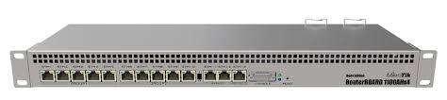 | Mikrotik RB1100AHX4 Dude Edition enterprise router  - Product code RB1100Dx4  - Architecture ARM 32bit  - CPU AL21400  - CPU core count 4  - CPU nominal frequency 1.4 GHz  - IPsec hardware acceleration  - Dimensions 443 x 148 x 44 mm  - RouterOS license 6  - Operating System RouterOS  - Size of RAM 1 GB  - Storage size 128 MB  - Storage type NAND  - MTBF Approximately 200'000 hours at 25C  - Tested ambient temperature -40°C to 70°C  - Suggested price $349.00  - Powering  - PoE in 802.3af/at  - PoE in input Voltage 20-57 V  - Number of AC inputs 2  - Number of DC inputs 2 (2-pin terminal, PoE-IN)  - 2-pin terminal input Voltage -48, 20-57 V  - Max power consumption 33 W  - Max power consumption without attachments 25 W  - FAN count Passive  - Ethernet  - 10/100/1000 Ethernet ports 13  - Peripherals  - Details  - Extended storage 60GB M.2 SSD included  - M.2 slots 2  - Memory card type microSD  - Memory Cards 1  - SATA ports 2x SATA3  - Serial port RS232
Table: 2; Computers into a new fast computer
PC Components | Name | Description&Specifications
Motherboard | ASUS ROG Strix B550-F Gaming (WiFi) AMD AM4 Motherboard | - Brand ASUS  - Processor SocketSocket AM4  - RAM Memory SizeDDR4  - Compatible Processor  - TypesAMD  - 3rd Generation Ryzen  - Chipset Type AMD B550
CPU | AMD Ryzen 5 2600X | - 2nd Generation Ryzen 5  - 6 CPU Cores  - 12 Threads  - 3.6GHz base frequency  4.2GHz max boost frequency
RAM | Kingstom HYPERX 8GB 2400MHz/2666MHz RAM Desktop Memory | - X424C15FB2/8 Type: 288-Pin DDR4 Capacity: 8GB (1x8GB) Speed: 8GB PC4-19200 DDR4 2400 MHz Voltage: 1.2V Heatsink: Black HX426C16FB2/8 Voltage: 1.2V Heatsink: Black Type: 288-Pin DDR4 Capacity: 8GB (1x8GB) Speed: 8GB PC4-21300 DDR4 2666 MHz
GPU | HeyTech Gainward GeForce RTX 2070 SUPER 8GB DDR6 (256 bits) PAC0011 | - GPU: GeForce RTX 2070 SUPER  - GPU Clockspeed:1815 MHz (Boost)  - Memory: 8GB GDDR6 (256 bits)  - Memory Clockspeed: 7000Mhz (14Gbps)  - Bandwidth:448 GB/s  - Bus PCI-Express: 3.0 x 16  - Cooling： 2.7 Slot fan cooler  - Video-Features：HDMI v2.0  - Connectivity：DisplayPort *3  - Product Size：292mm x 130mm  - Power Connector： 8-pin *2
Storage | WD Western Digital Blue 1TB/2TB/3TB/4TB Desktop Hard Disk Drive - 5400 RPM SATA  No Ratings | - 5400 RPM SAT  - Capacity: 2TB
PSU | True Rated Power Supply | - Unit 500w
Computer Case | Gigaware Computer Gaming Time Tunnel CPU Case | - Motherboard support: ATX/MICRO-ATX/ITX  - Chassis size: 380mmx195mmx430mm  - Graphics card length: no more than 330mm  - CPU radiator height limit: 150mm  - Hard disk position: 2.5-inch SSD solid state drive x3, 3.5-inch HHD mechanical hard drive X1  - Front interface: headphone/microphone interface,  - USB2.0x2, USB3.0X1  - Heat dissipation position: front panel 120mmX3 (or 240 water-cooled X1), top 120mmx2, back 120mmx1 (or 120 water-cooled X1)  - Chassis size: 380mmx195mmx430mm
UPS | Secure UPS 1500VA Uninterruptible Power Supply | - Brand: Secure  - Model: 1500VA  - Input Voltage Range: 145-295VAC  - Input Frequency: 50 or 60 Hz (auto sensing)  - Output Voltage Range: 230VAC  - Output Frequency: 50 or 60 Hz  - Transfer Time: 2-6ms  - Dimension(mm): D325*W139*H210  - Typical Recharge Time: 9-10hours  - Protection: Automatic self-test & discharge protection, replace battery indicator  - Backup Time 3-15 minutes more or less (depending on actual load)
Monitor | Samsung S24R350 24 | - 1920 x 1080 Full HD Resolution  - 75Hz Refresh Rate  - VGA, HDMI (1.4) Video Input  - AMD FreeSync Technology  - Tilt Adjustable  - VESA Mount Compatible
Keyboard | Dell KB216 keyboard | - Multimedia keys for quick actions and commands  The convenient multimedia keys let you easily access functions such as play, pause, rewind, and fast-forward plus volume control.
Mouse | Logitech G102 IC PRODIGY | - Advanced key tension system  Simply click the same  Advanced key tension system to the left and right mouse button in the click-to-be state, reducing the click of the required pressure, while achieving excellent keystroke feel, response and stability.

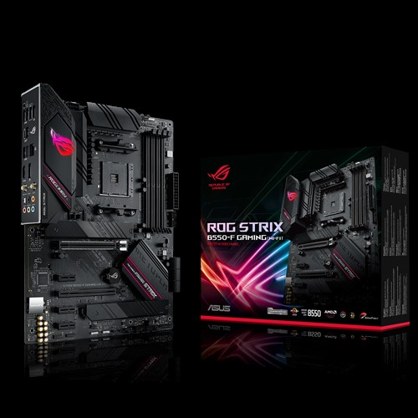
ASUS ROG Strix B550-F Gaming (WiFi) AMD AM4 Motherboard

*AMD Ryzen 5 2600X
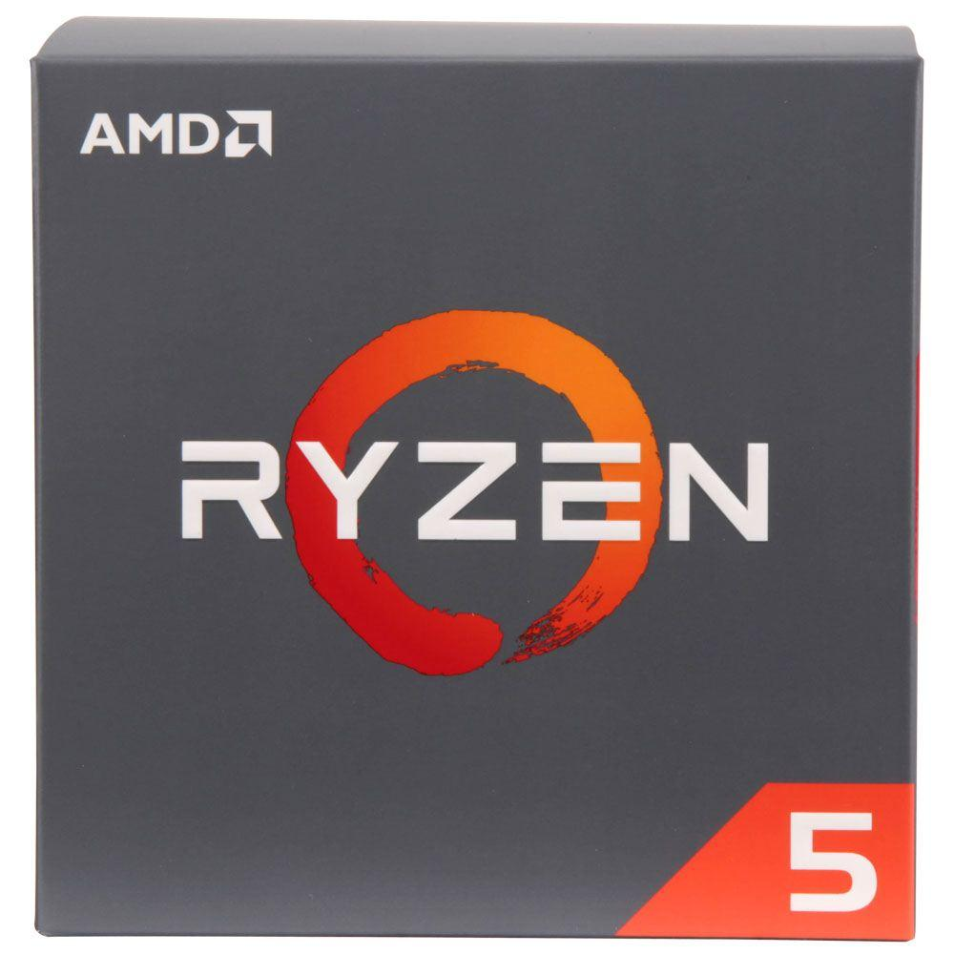

*2600X Kingston HYPERX 8GB 2400MHz/2666MHz RAM Desktop Memory
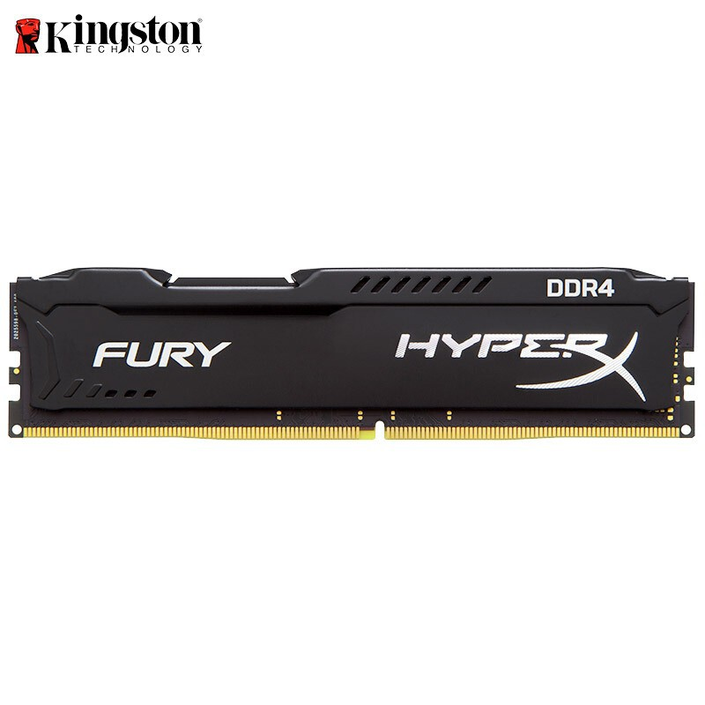

HeyTech Gainward GeForce RTX 2070 SUPER 8GB DDR6 (256 bits) PAC0011
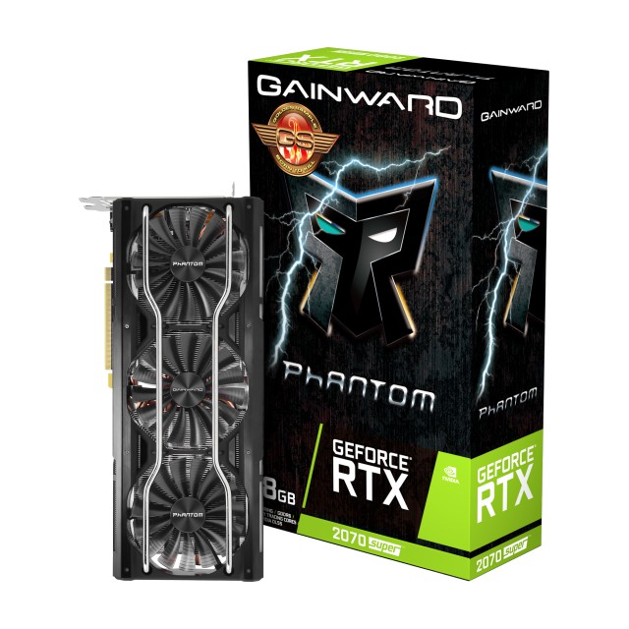

WD Western Digital Blue 1TB/2TB/3TB/4TB Desktop Hard Disk Drive - 5400 RPM SATA
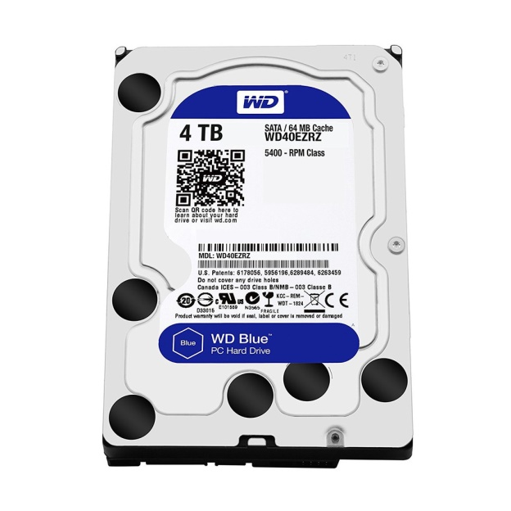

True Rated Power Supply
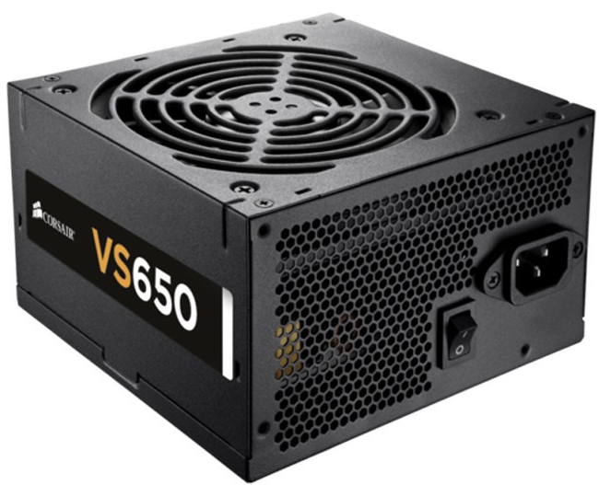

Gigaware Computer Gaming Time Tunnel CPU Case
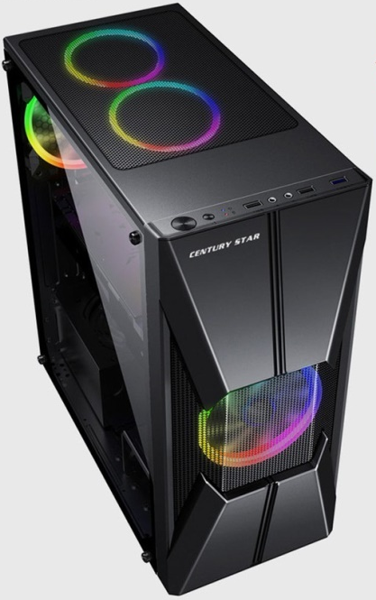

Secure UPS 1500VA Uninterruptible Power Supply
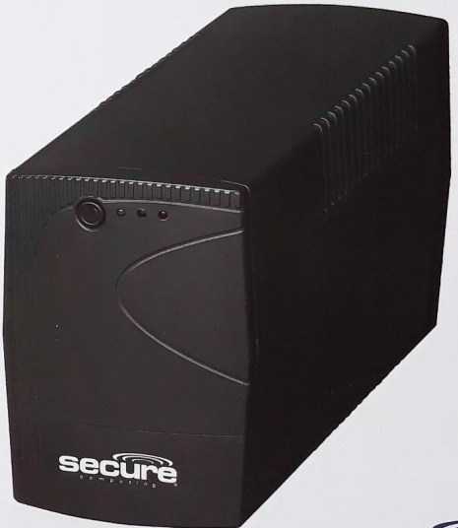

Samsung S24R350 24
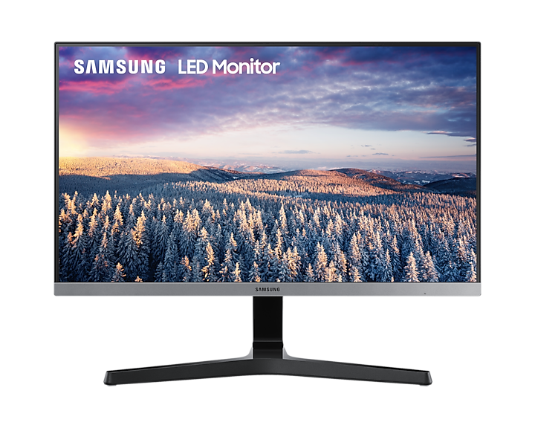

Logitech G102 IC PRODIGY
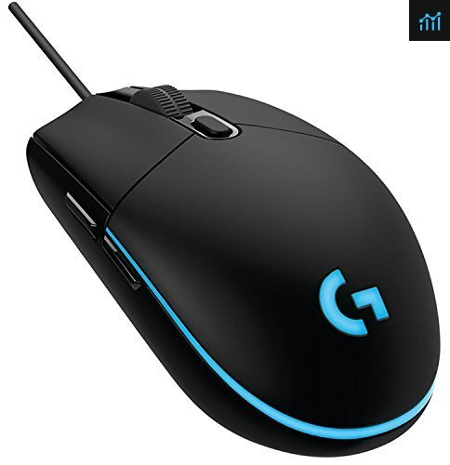
Dell KB216 keyboard
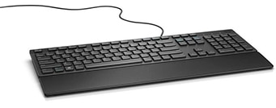
Table 3; Upgrade their iPad Pro, or Similar high-end Android tablet
Technology Device | Specifications & description
Samsung Tab A | - Galaxy Tab A from Samsung. This tablet features a Samsung Exynos 7870 chipset, which utilizes an octa-core processor clocked at speeds up to 1.6 GHz. It comes with 2GB of RAM and 16GB of built-in storage. It's also equipped with a microSD slot that supports microSDXC cards for additional storage space. For high-speed Internet connectivity, 802.11a/b/g/n/ac Wi-Fi is built-in. Bluetooth 4.2 connectivity is also integrated for pairing with Bluetooth-enabled devices, such as select headphones and accessories.  • 1026 x 768 Display  • Processor 1.2GHz Quad-core  • Front camera: 2MP  • RAM: 2GB  • OS Android: KitKat 5.0  • Storage: 16GB  • Rear Camera: 5MP  • Battery Capacity: 4200mAh

Table 4; Buying a new Dell Power edge NX3240 latest generation PowerEdge rack mount server technology
Mikrotik RB1100AHX4 Dude Edition enterprise router | Mikrotik RB1100AHX4 Dude Edition enterprise router  - Product code RB1100Dx4  - Architecture ARM 32bit  - CPU AL21400  - CPU core count 4  - CPU nominal frequency 1.4 GHz  - IPsec hardware acceleration  - Dimensions 443 x 148 x 44 mm  - RouterOS license 6  - Operating System RouterOS  - Size of RAM 1 GB  - Storage size 128 MB  - Storage type NAND  - MTBF Approximately 200'000 hours at 25C  - Tested ambient temperature -40°C to 70°C  - Suggested price $349.00  - Powering  - PoE in 802.3af/at  - PoE in input Voltage 20-57 V  - Number of AC inputs 2  - Number of DC inputs 2 (2-pin terminal, PoE-IN)  - 2-pin terminal input Voltage -48, 20-57 V  - Max power consumption 33 W  - Max power consumption without attachments 25 W  - FAN count Passive  - Ethernet  - 10/100/1000 Ethernet ports 13  - Peripherals  - Details  - Extended storage 60GB M.2 SSD included  - M.2 slots 2  - Memory card type microSD  - Memory Cards 1  - SATA ports 2x SATA3  - Serial port RS232

Mobile Device | Specifications & description
Samsung Tab A | - 1026 x 768 Display  - Processor 1.2GHz Quad-core  - Front camera: 2MP  - RAM: 2GB  - OS Android: KitKat 5.0  - Storage: 16GB  - Rear Camera: 5MP  - Battery Capacity: 4200mAh
Table 5; Buying new Ipad or similar to Galaxy

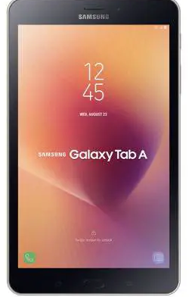

Cost including the shipping fee
Client part hardware and software (x 30 clients):
Hardware/  Software type | Name | Prices  (in Philippine peso, unless indicated with currency)
Operating System | Windows 10 Pro | ₱8,990.00
Motherboard | ASUS ROG Strix B550-F Gaming (WiFi) AMD AM4 Motherboard | ₱10,240.99
CPU | AMD Ryzen 5 2600X | ₱5,985.00
GPU | HeyTech Gainward GeForce RTX 2070 SUPER 8GB DDR6 (256 bits) PAC0011 | ₱8,624.00
Storage | WD Western Digital Blue Desktop Hard Disk Drive | ₱1,567.00
RAM | Kingstom HYPERX 8GB 2400MHz/2666MHz RAM Desktop Memory | ₱2,024
Computer case | Gigaware Computer Gaming Time Tunnel CPU Case | ₱1,879.00
PSU | True Rated Power Supply | ₱650.00.
UPS | Secure UPS 1500VA Uninterruptible Power Supply | ₱3,999.00
Keyboard | Dell Wired Keyboard - Black KB216 | ₱3,979.00
Mouse | Logitech G102 IC PRODIGY | ₱1,608.00
Monitor | Samsung S24R350 24 | ₱5,538.39

Total Cost: ₱2,346,314.65

New Ipad or similar to Galaxy
Mobile Device | Specifications & description
Samsung Tab A | ₱7,439.99

Total Cost: 267,705

Router ;
Mikrotik RB1100AHX4 Dude Edition enterprise router  Mikrotik RB1100AHX4 | Mikrotik RB1100AHX4 Dude Edition enterprise router  ₱31,990.00

Total Cost= 95,970

Server;

Total Cost= 361,200.00
Overall Cost
395,970 + 61,200.00 + ₱2,346,314.65 + 267,705= 3,071,189.65

PowerVault NX3240  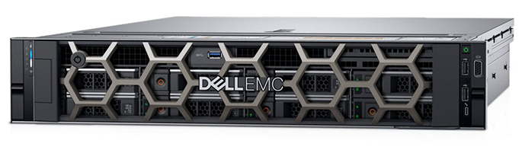 | PowerVault NX3240  ₱361,200.00

