Mikrotik RB1100AHX4 Dude Edition enterprise router  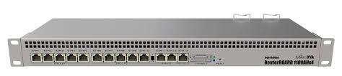 | Mikrotik RB1100AHX4 Dude Edition enterprise router  Details;  - Product code RB1100Dx4  - Architecture ARM 32bit  - CPU AL21400  - CPU core count 4  - CPU nominal frequency 1.4 GHz  - IPsec hardware acceleration  - Dimensions 443 x 148 x 44 mm  - RouterOS license 6  - Operating System RouterOS  - Size of RAM 1 GB  - Storage size 128 MB  - Storage type NAND  - MTBF Approximately 200'000 hours at 25C  - Tested ambient temperature -40°C to 70°C  - Suggested price $349.00  - Powering  - PoE in 802.3af/at  - PoE in input Voltage 20-57 V  - Number of AC inputs 2  - Number of DC inputs 2 (2-pin terminal, PoE-IN)  - 2-pin terminal input Voltage -48, 20-57 V  - Max power consumption 33 W  - Max power consumption without attachments 25 W  - FAN count Passive  - Ethernet  - 10/100/1000 Ethernet ports 13  - Peripherals  - Details  - Extended storage 60GB M.2 SSD included  - M.2 slots 2  - Memory card type microSD  - Memory Cards 1  - SATA ports 2x SATA3  - Serial port RS232

APC 5000VA Rack Mount UPS Uninterruptible Power Supply, 230V Output, 4kW - Line Interactive  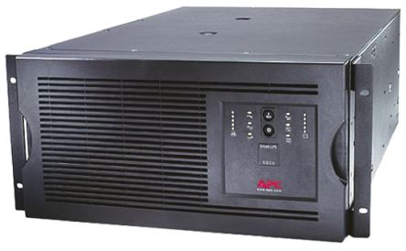 | APC 5000VA Rack Mount UPS Uninterruptible Power Supply, 230V Output, 4kW - Line Interactive  Details;  - Alpha/numeric LCD display  - Smart Slot  - Cold-start capable  - Hot-swappable batteries  - Battery disconnect  - Automatic self-test  - Automatic restart of loads after UPS shutdown  - Audible alarms  - Nominal output voltage is 230V  - DB9, RS232, smart slot communications  - Network manageable  - Rack/Tower convertible

